# CS278 ASSIGNMENT #6: Conditional Branching & State Machines

## NAME: DUE: Nov 15 Received: .

**GRADE:**

|  |  |  |
| --- | --- | --- |
| **CATEGORY** | **POINTS** |  |
| **EX06_01_Review** |  | 10 |
| **EX06_02_Review** |  | 10 |
| **EX06_03_Filling_Array** |  | 20 |
| **EX06_04_Test_Score** |  | 30 |
| **EX06_05_Colors** |  | 30 |
| **TOTAL** |  | 100 |

## EXERCISES:

* For ALL of these exercises, you **will** **need** **the** **Debugger** to verify that your code is working correctly.
* Secondly, **your MUST document your code**. Describe the approach your code is taking, how it's doing what it's doing. Up to 5 points per problem may be deducted if you don't describe what you are doing in a way that someone else reading your code can understand what your code is doing.
* One suggestion is to document your code with the equivalent C++ syntax (e.g. if statements, for loop, etc.)
* You MUST use indenting to format loops so that we can follow your code. Make loop and variable labels descriptive.

**EX06_01_Review –** Answer section review exercises 6.2.11: 1,4,5

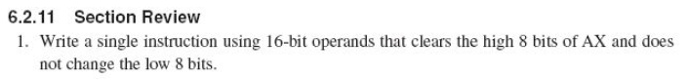

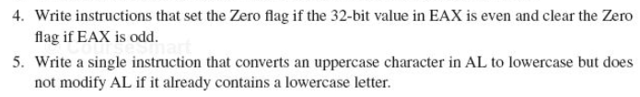

1. and ax, 00FFh

4. test eax, 1

5. or al, 00100000b

**EX06_02_Review –** Answer section review exercises 6.3.5: 1-6

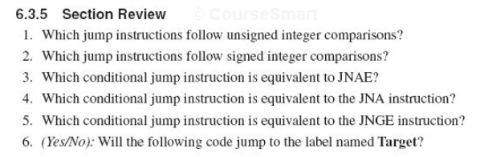

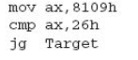

1. JA, JNBE, JAE, JNB, JB, JNAE, JBE, JNA
2. JG, JNLE, JGE, JNL, JL, JNGE, JLE, JNG
3. JB
4. JBE
5. JL
6. No

**EX06_03_Filling_Array –** Do Programming Exercise 6.11.2.1

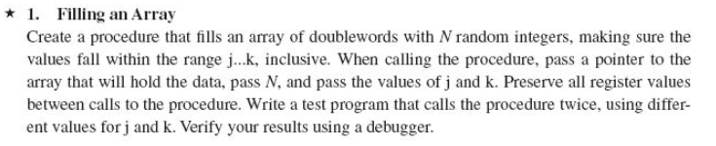

**EX06_04_Test_Score –** Do Programming Exercise 6.11.2.3

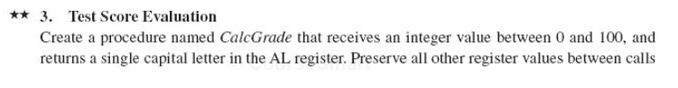

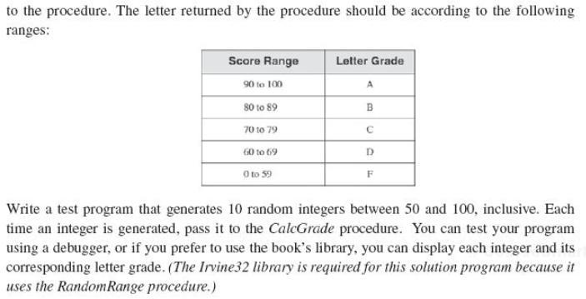

**EX06_05_Colors –** Do Programming Exercise 6.11.2.7

